Market Basket Analysis In Multi-Store Environment
Dakshay Nerkar, Ronak Shah, Bhavin Patel
Computer Department, Sardar Patel Institute of Technology, Mumbai University
Mumbai-400058,India
nerkar.dakshay@gmail.com
ronakshah725@gmail.com
bhavin.j.patel@gmail.com

Abstract— Market basket analysis is an important component of analytical system in retail organizations to determine the placement of goods, designing sales promotions for different segments of customers to improve customer satisfaction and hence the profit of the supermarket. These issues for a leading supermarket are addressed here using frequent itemset mining. The frequent itemsets are mined from the market basket database using the efficient Apriori algorithm and then the association rules are generated. Because the information obtained from the analysis can be used in forming marketing, sales, service, and operation strategies, it has drawn increased research interest. The existing methods, however, may fail to discover important purchasing patterns in a multi-store environment, because time-analysis is not considered substantial in these methods .Our time-based method shows that the proposed method is computationally efficient and that it has advantage over the traditional method when stores are diverse in size, product mix changes rapidly over time, and larger numbers of stores and periods are considered.

Keywords— Include at least 5 keywords or phrases
- Introduction

One of the challenges for companies that have invested heavily in customer data collection is how to extract important information from their vast customer databases and product feature databases, in order to gain competitive advantage. Several aspects of market basket analysis have been studied in academic literature, such as using customer interest profile and interests on particular products for one to-one marketing, purchasing patterns in a multi-store environment to improve the sales. Market basket analysis has been intensively used in many companies as a means to discover product associations and base a retailer’s promotion strategy on them.
Informed decision can be made easily about product placement, pricing, promotion, profitability and also finds out, if there are any successful products that have no significant related elements. Similar products can be found so those can be placed near each other or it can be cross-sold. A retailer must know the needs of customers and adapt to them. Market basket analysis is one possible way to find out which items can be put together. Market Basket Analyses gives retailer goods information about related sales on group of goods basis. Customers who buy’s bread often buys several products related to bread like milk, butter or jam. It makes sense that these groups are placed side by side in a retail center so that customers can access them quickly. Such related groups of goods also must be located side-by-side in order to remind customers of related items and to lead them through the center in a logical manner. Market basket analysis is one of the data mining methods focusing on discovering purchasing patterns by extracting associations or co-occurrences from a store’s transactional data. Market basket analysis determines the products which are bought together and to reorganize the supermarket layout, and also to design promotional campaigns such that products’ purchase can be improved.
Hence, the Market consumer behaviors need to be analyzed, which can be done through different data mining techniques. Data mining finds interesting patterns from databases such as association rules, correlations, sequences, classifiers, clusters and many more of which the mining of association rules is one of the most popular problems.

- System architecture

- Design Approach

Analysis based applications are built using several components connected to one another, each providing a specific functionality. Components that perform similar types of functions are generally grouped into layers. These layers are further organized as a stack in which components in a higher layer use the services of components in the layer below. A component in a given layer will generally use the functionality of other components in its own layer or the layers below it. The diagram below shows a popular layer structure for an analysis application.

- Presentation Layer: The presentation layer contains components needed to interact with the user of the application. Examples of such components are web pages, rich-client forms, user interaction process components etc.

- Business Layer: The business layer encapsulates the core business functionality of the application. Simple business functions can be implemented using stateless components whereas complex long running transactions can be implemented using stateful workflows. The business components are generally front-ended by a service interface that acts as a facade to hide the complexity of the business logic. This is commonly known as Service-Oriented Architecture (SOA).

- Data Access Layer: The data access layer provides a simple API for accessing and manipulating data. The components in this layer abstract the semantics of the underlying data access technology thus allowing the business layer to focus on business logic. Each component typically provides methods to perform Create, Read, Update, and Delete (CRUD) operations for a specific business entity.

- Data Stores: Enterprise applications store their data in one or more data stores. Databases and file systems are two very common types of data stores.
- Proposed System Architecture
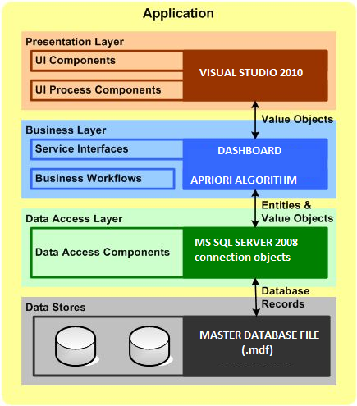
Fig. 2 Proposed System Architecture

2.1 Presentation Layer: Our UI consists of an environment run in Visual Studio 2010 .It is supported by user-friendly buttons and check boxes to help even the lay-man use the application. Graphs, pie-charts and bar charts are also displayed as part of displaying strong rules and frequently appearing item-sets.

2.2: Business Layer: The business layer generated by our application consists primarily of services that generated from classes defined in the model. These services can be used directly as application code. Apriori algorithm is applied with the combination of time series to analyze the data with their time stamps.

2.3: Data Access Layer: To connect to the database, SQL SERVER 2008 connection objects are used. Using the basic connection strings of the SQL server, the database is connected to the application.

3.2.4: Data Stores : Multiple-databases from different locations are connected together through relational databases. The database are updated real-time when transactions are added and the admin can see these changes in the database. An MDF file database is generated to export to remote locations to run on different local machines.

C. Representation of Analysis

Dashboard is "An easy to read, often single page, real-time user interface, showing a graphical presentation of the current status (snapshot) and historical trends of an organization’s key performance indicators (KPIs) to enable instantaneous and informed decisions to be made at a glance." Dashboards often provide at-a-glance views of KPIs relevant to a particular objective or business process (e.g. sales, marketing, human resources, or production Dashboards give signs about a business letting you know something is wrong or something is right. The corporate world has tried for years to come up with a solution that would tell them if their business needed maintenance or if the temperature of their business was running above normal. Dashboards typically are limited to show summaries, key trends, comparisons, and exceptions. There are four Key elements to a good dashboard:
1.Simple,communicate easily
2.Minimum distractions…it could cause confusion
3.Supports organized business with meaning and useful data
4.Applies human visual perception to visual presentation of information

D. Proposed Algorithms

Apriori is a classic algorithm for learning association rules. Apriori is designed to operate on databases containing transactions (for example, collections of items bought by customers, or details of a website frequentation).As is common in association rule mining, given a set of item sets (for instance, sets of retail transactions, each listing individual items purchased), the algorithm attempts to find subsets which are common to at least a minimum number C of the item sets. Apriori uses a "bottom up" approach, where frequent subsets are extended one item at a time (a step known as candidate generation), and groups of candidates are tested against the data. The algorithm terminates when no further successful extensions are found.The purpose of the Apriori Algorithm is to find associations between different sets of data. It is sometimes referred to as "Market Basket Analysis". Each set of data has a number of items and is called a transaction. The output of Apriori is sets of rules that tell us how often items are contained in sets of data.Apriori uses breadth-first search and a Hash tree structure to count candidate item sets efficiently. It generates candidate item sets of length k from item sets of length k-1 .Then it prunes the candidates which have an infrequent sub pattern.According to the downward closure lemma, the candidate set contains all frequent -length item sets. After that, it scans the transaction database to determine frequent item sets among the candidates.Bottom-up subset exploration (essentially a breadth-first traversal of the subset lattice) finds any maximal subset S only after all 2^{|s|}-1 of its proper subsets.

Data generation method and Data Format :

In the experiment, we randomly generate the synthetic transactional data sets by applying the data generation algorithm proposed . Since this study focus on identifying important purchasing patterns in a multi-store environment, three more factors are considered in the study:
(1) the numbers of stores and periods
(2) the store size
(3) the product replacement ratio.

The factors considered in the simulation
are listed in Table 1. In addition, we generate the time and store information for each
transaction in the data sets.
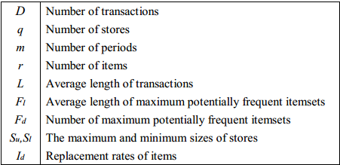

Table 1. Parameters used in data generation

To generate the store sizes, we use two parameters, Su and Sl, to represent the
largest and smallest store sizes, respectively, and the size of store i for 1 ≤ i ≤ q,
denoted by Si, is generated by a uniform distribution between Su and Sl. We assume
that the total number of transactions and the number of products are dependent on a store’s size. In addition, we also allow the stores to have different product
replacement (turnover) ratios. In the simulation, these relationships are established by
generating m random numbers for the store i from a Poisson distribution with mean Si,
and we use the jth number, denoted by Wij , as the weight of store i in period j. Let Dij
denote the number of transactions of store i in period j. The total number of
transactions, D, is distributed to the store i, and period j is determined by :

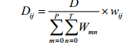

Further ,we assume that the number of products in a store is proportional to square root of its size. Thus , let ISi = Si for i= 1,2,3………q. Then, the number of product in store i, denote by Ni , is determined by the following formula :
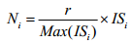

Parameters Setting :

To generate the nine types of data sets shown in Table 2, we use the following
parameter values: r = 1000, D = 100K, L = 6, Fl = 4, and Fd = 1,000. For each type of
the data sets, 10 replications are generated for statistical analysis of the results.

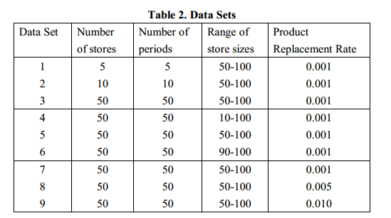

Time Series Analysis:
Time Series Analysis concerns the analysis of data collected over time .Weekly values, monthly values, quarterly values, yearly values, etc. Usually the intent is to discern whether there is some pattern in the values collected
to date, with the intention of short term forecasting (to use as the basis of
business decisions).

yt = response of interest at time t
Smoothing Time Series :

There are various fairly simple smoothing/averaging methods.
Two are "ordinary moving averages" and "exponentially weighted moving averages."

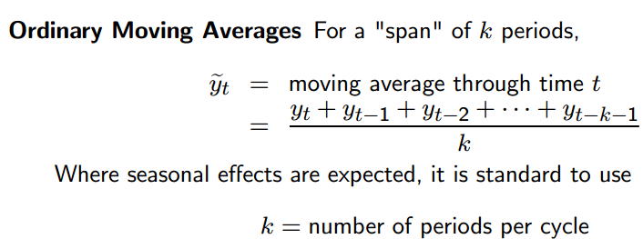

Where seasonal effects are expected, it is standard to use :

k = number of periods per n summary

We state that :
The "simple" , “average” or “mean” of all past observations is only a useful estimate for forecasting when there are no trends. If there are trends, use different estimates that take the trend into account. The average "weighs" all past observations equally.

For example, the average of the values 3, 4, 5 is 4. We know, of course, that an average is computed by adding all the values and dividing the sum by the number of values. Another way of computing the average is by adding each value divided by the number of values, or
3/3 + 4/3 + 5/3 = 1 + 1.3333 + 1.6667 = 4.

The multiplier 1/3 is called the weight. In general:

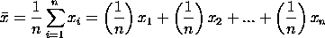

The are the weights and of course they sum to 1.

- Development and Implementation

  - Tools and Technologies Implemented

We have implemented the Apriori algorithm for our Windows based Market Basket Analysis. Our application is based on Software Oriented Architecture.
Tools Used for System Development:
- Microsoft Visual Studio 2010
- Microsoft SQL Server 2008
- Visual C Sharp

  - Database Implementation

The database has been implemented using Microsoft SQL Server 2008. A relational database has been designed to manage multiple stores in a single database.
- Conclusion

- The project demonstrates the use of Apriori Algorithm to project the generation of various association rules.

- Traditional Associations rule mining was introduced in 1993 by Agrawal fail in multi store environment.

- To overcome this, store-chain association rule is proposed where store and period are involved.

- A simulation is used to compare the proposed and traditional methods. We have seen that algorithm is computationally efficient.

- The outcomes would be used for general or local marketing strategies. Moreover for product procurement, inventory, distribution strategies for store-chain.

- This is the promising research area in data mining ,lot of work is left to do like generating store-chain association rules accurately and efficiently, to extend this algorithm for multiple levels in distributed environment.

- Future Scope

Recent advances in the ability to collect and process transaction-level (TLog) data, coupled with exponential increases in computational power and much cheaper storage, all made it possible for grocers, c-stores and other retailers to build in-house or purchase market basket analytic software. Unfortunately, almost all of these solutions deliver non-actionable insights based on affinity analysis.The healthcare practitioners , often feel as though they are drowning in a sea of gathered data that continues to swell. To help the life sciences community sustain the pace of discovery -- and deliver next-generation treatments more quickly and affordably -- the industry is embracing advanced data-mining techniques and technologies.Market basket analysis of futuristic models use statistical analysis, artificial intelligence, and machine learning technologies to identify patterns that could not be found by manual analysis alone.Continued maturation of the technology in recent years has expanded its capabilities and stature as a vital tool in the drug discovery process. New data-mining applications feature expanded analytics, user-friendly interfaces, and powerful algorithms that allow researchers to analyze structured and unstructured data. “With training, data mining can now be done on a personal computer with a number of different commercial and open source data mining software packages.”In a healthcare delivery environment, providers can use predictive analytics to forecast medical outcomes; find factors associated with the highest-cost patients, doctors, and care facilities; and even detect insurance fraud. In addition, pharmaceutical manufacturers can use the technology to increase the efficiency and effectiveness of their marketing initiatives, predicting which doctors are most likely to prescribe new drugs and identifying patients most likely to be high-value customers.
Predictive analytics isn’t a panacea. “Garbage in; garbage out” still applies -- but it’s based on the concept that some advanced (and highly automated) analysis is better than no analysis.Text mining enables, for the first time, automated integration of unstructured clinical data and structured genomic data. There is tremendous data in patient files that -- when anonymized and harvested, combined with genomic, proteomic, and phenotypic data, and then data-mined -- will yield amazing new discoveries. For example, a healthcare facility may have extensive information on a local population’s health histories, eating, and exercise habits. With text and data mining, it could harvest and analyze this information, potentially identifying patients with the greatest risk for chronic long-term hypertension, cancer, and many other diseases.

VI.References

- Temporal databases and association rules
http://www.acm.org/conferences/sac/sac2000/Proceed/FinalPapers/DB-04/
- Dashboard concepts
http://en.wikipedia.org/wiki/Dashboard_(business)
- Market basket analysis in a multi store environment
http://moe.ecrc.nsysu.edu.tw/Chinese/DatabaseC/10-1_Chen.pdf
- Leading Practices in Market Basket analysis
http://factpoint.com/pdf2/1.pdf
- Aproiri algorithm and time series analysis
http://www.cs.sunysb.edu/~cse634/lecture_notes/07apriori.pdf
- Time series analysis methods ( simulation and modeling by law and kelton )
- Advance association algorithms ( data mining by margaret dunham).

